Linux Tasks
- Create user with name Techie and provide sudo access to user.
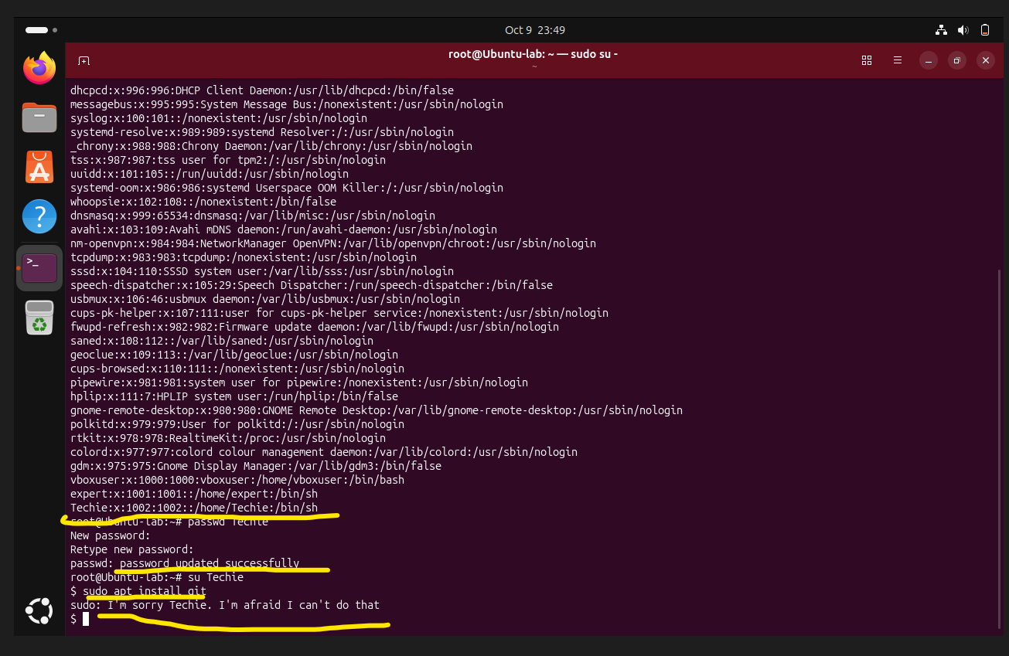
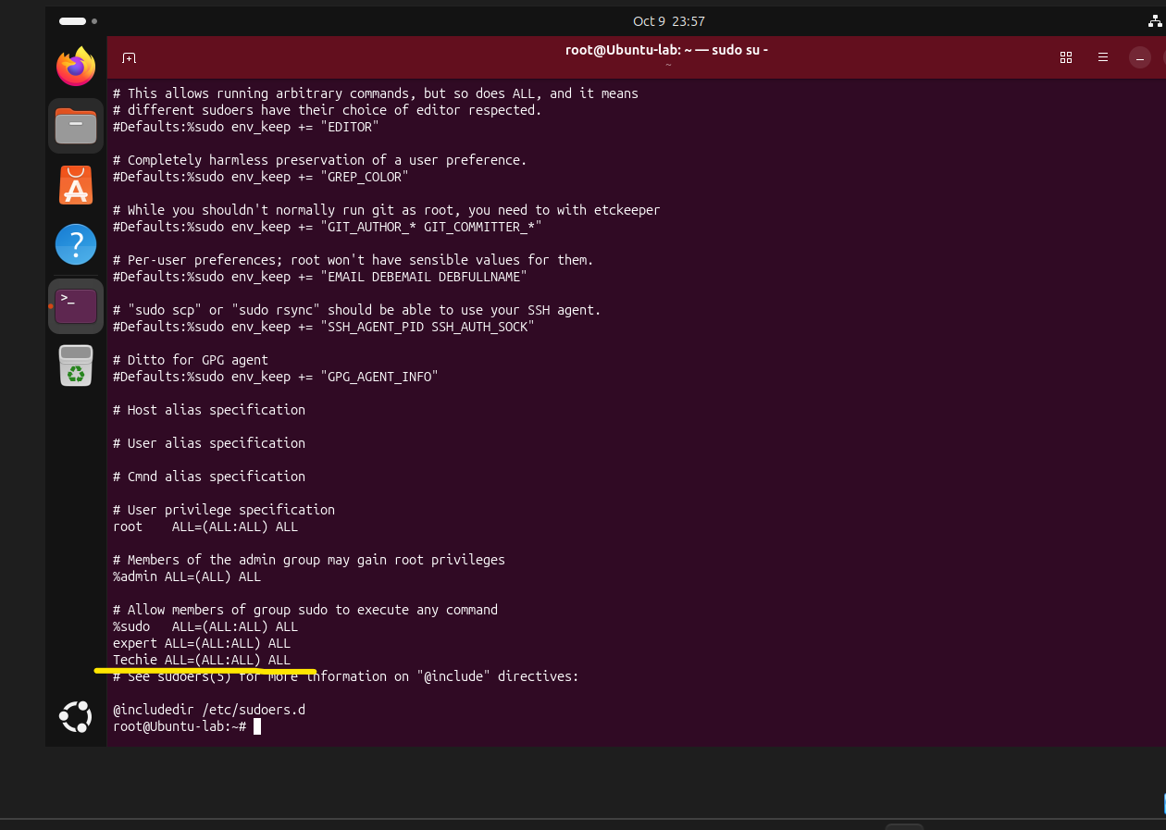I just added the sudo access for Techie User through Nano…
Option :2
We can use this command usermod -aG sudo Techie
- Navigate to the home directory.
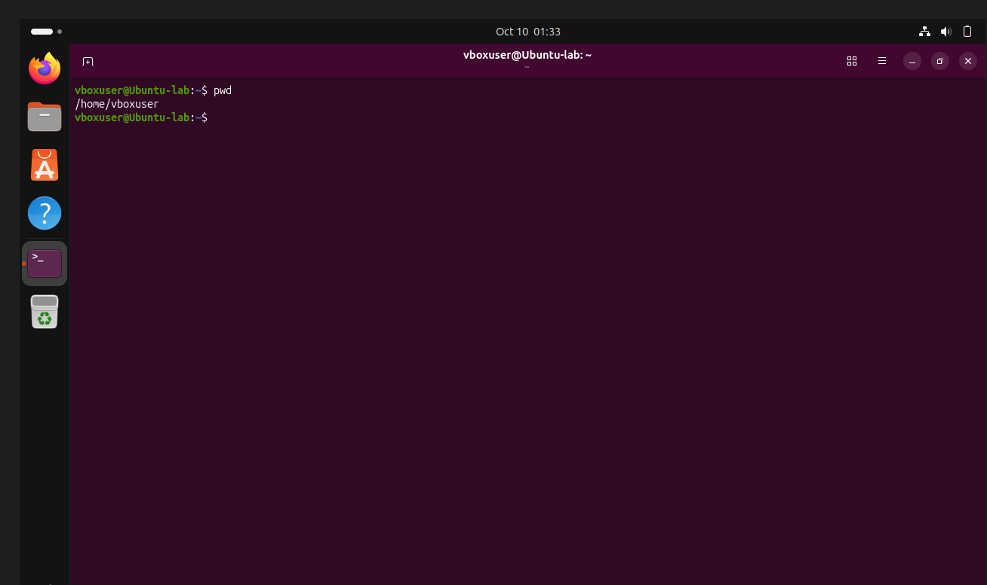
- Create a new directory.
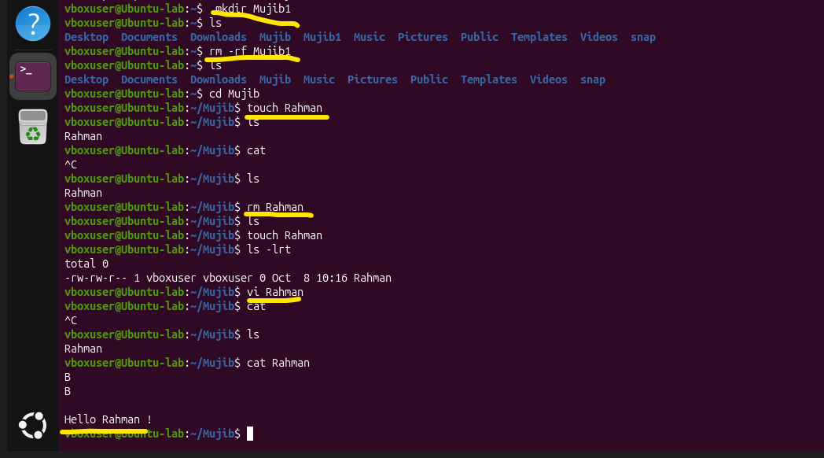
- List the contents of a directory.
- Change the current directory.
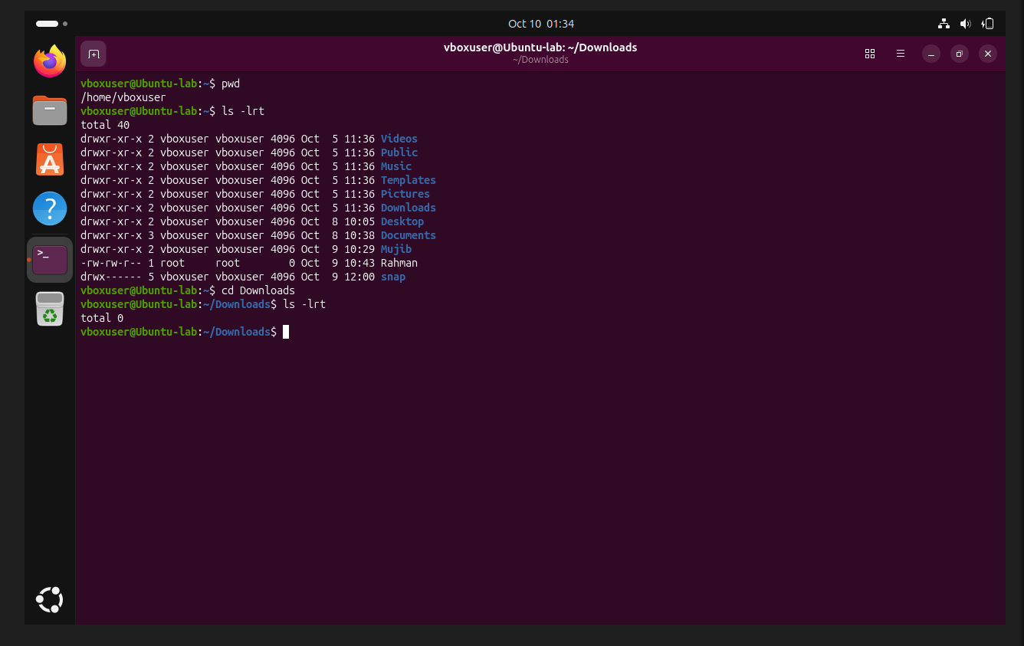
- Create a new empty file.
- View the contents of a file.
- Copy a file to another location.
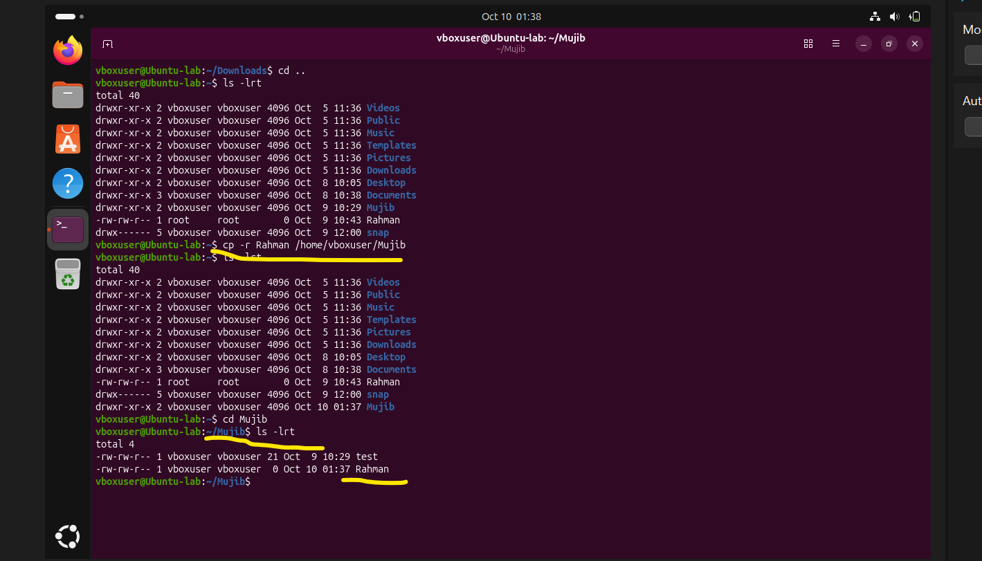
- Move a file to another location.
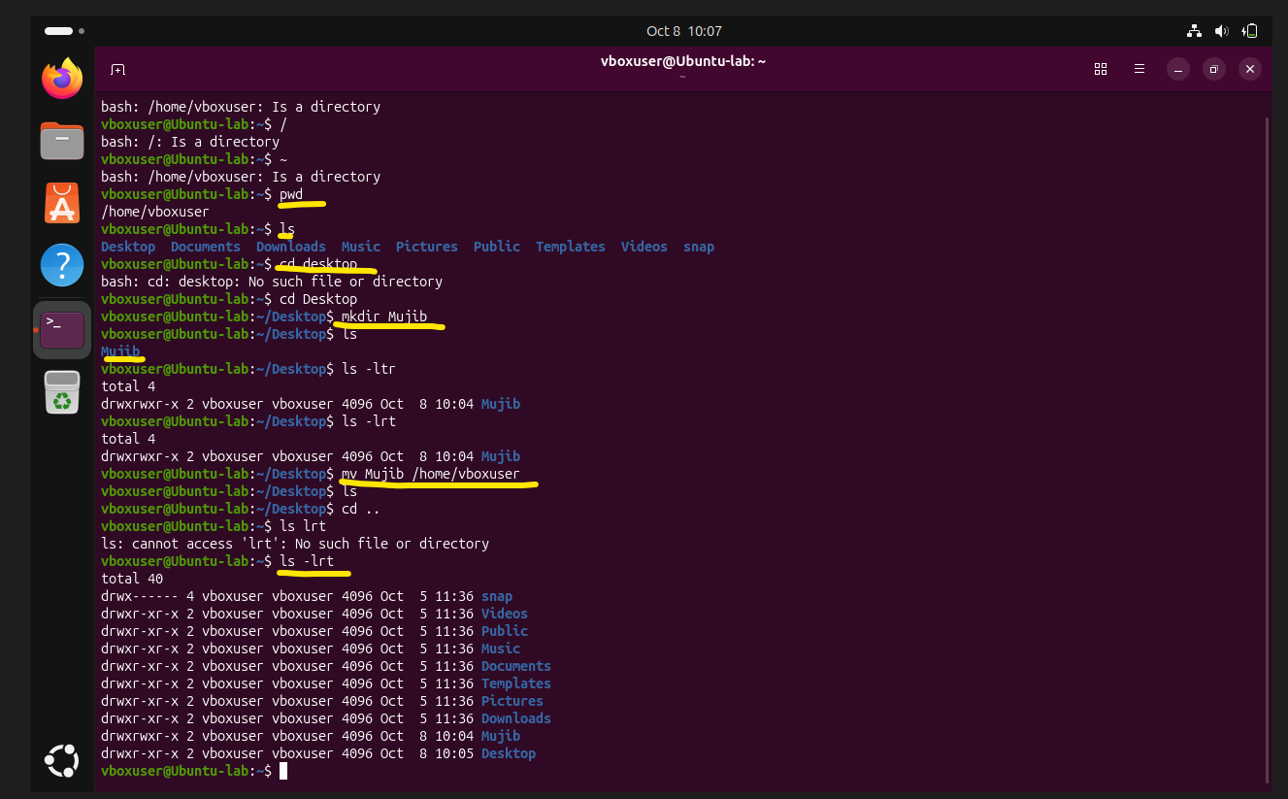
- Rename a file.
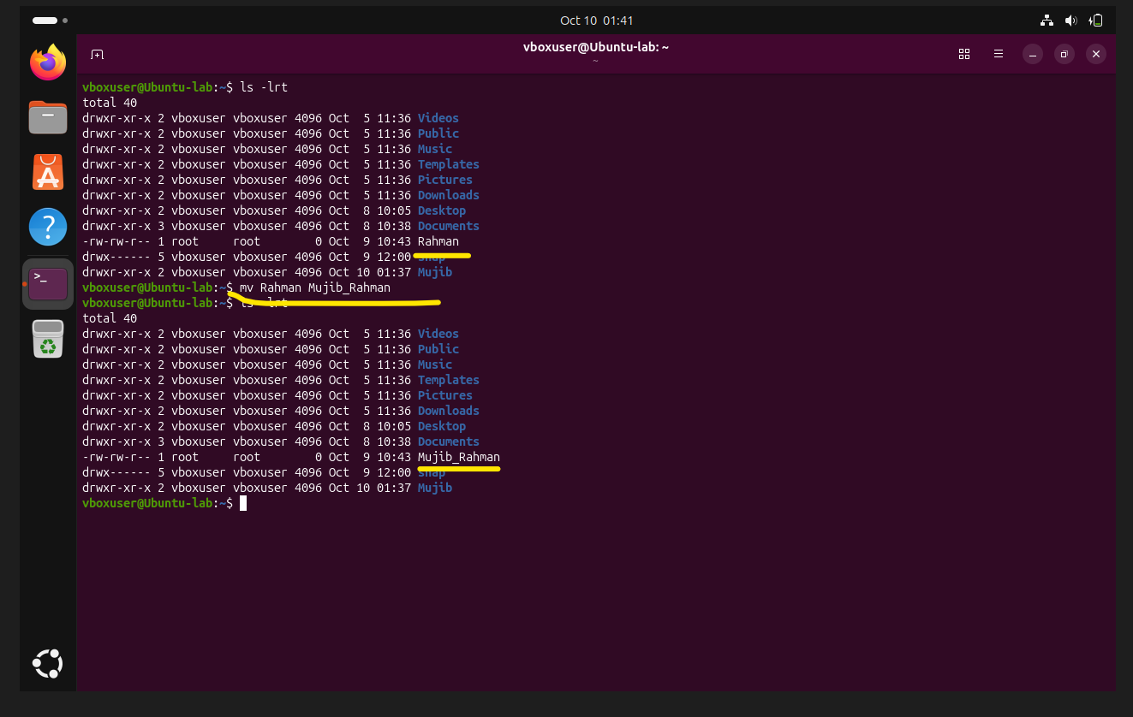
- Delete a file.
- Grant or revoke permissions on a file or directory.
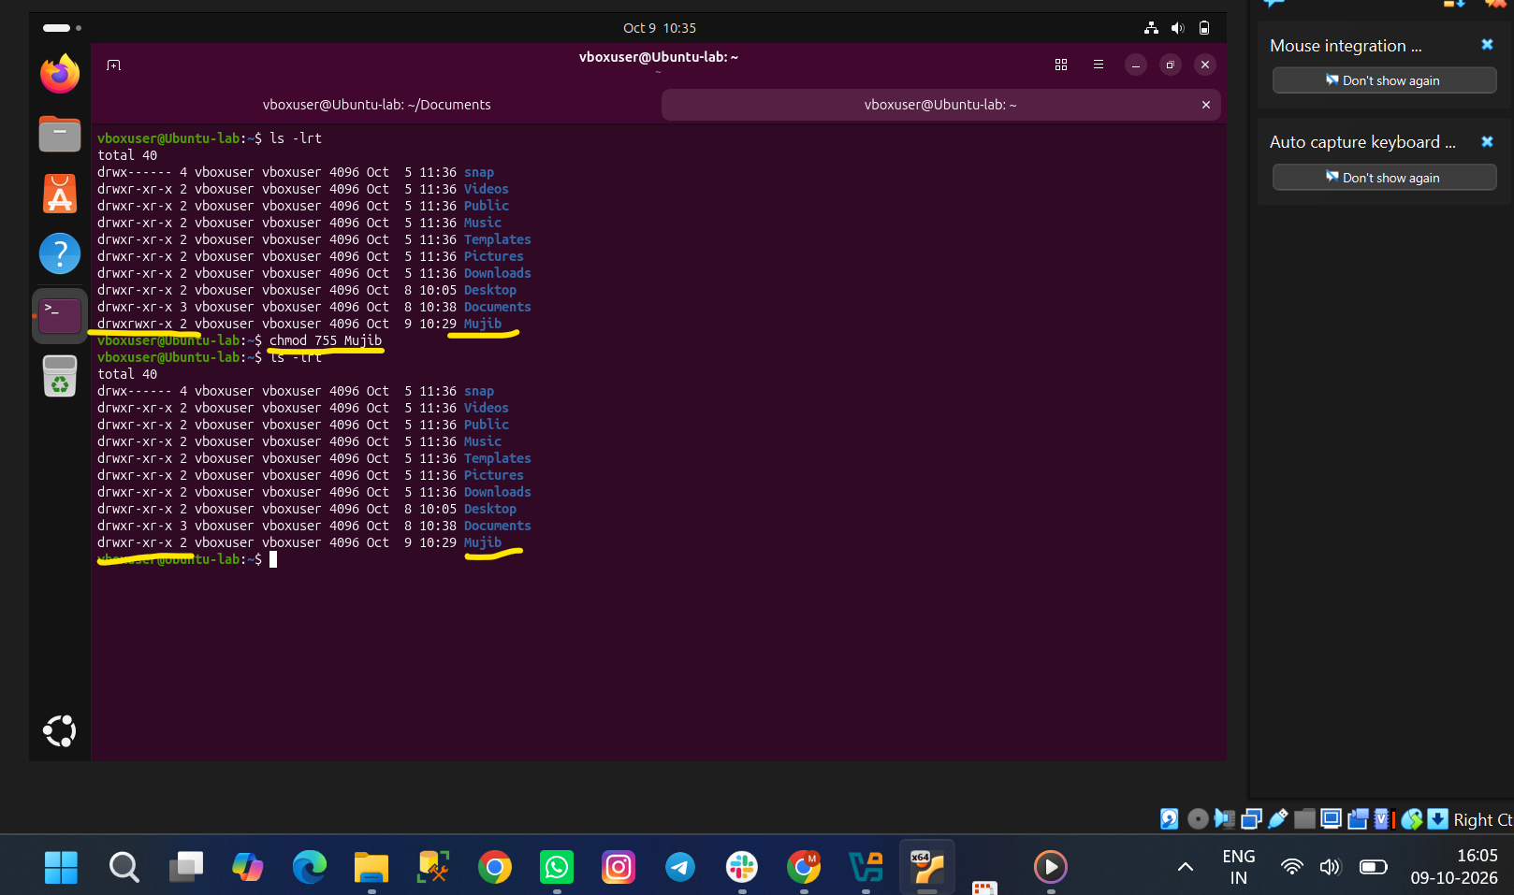
- View the current date and time.
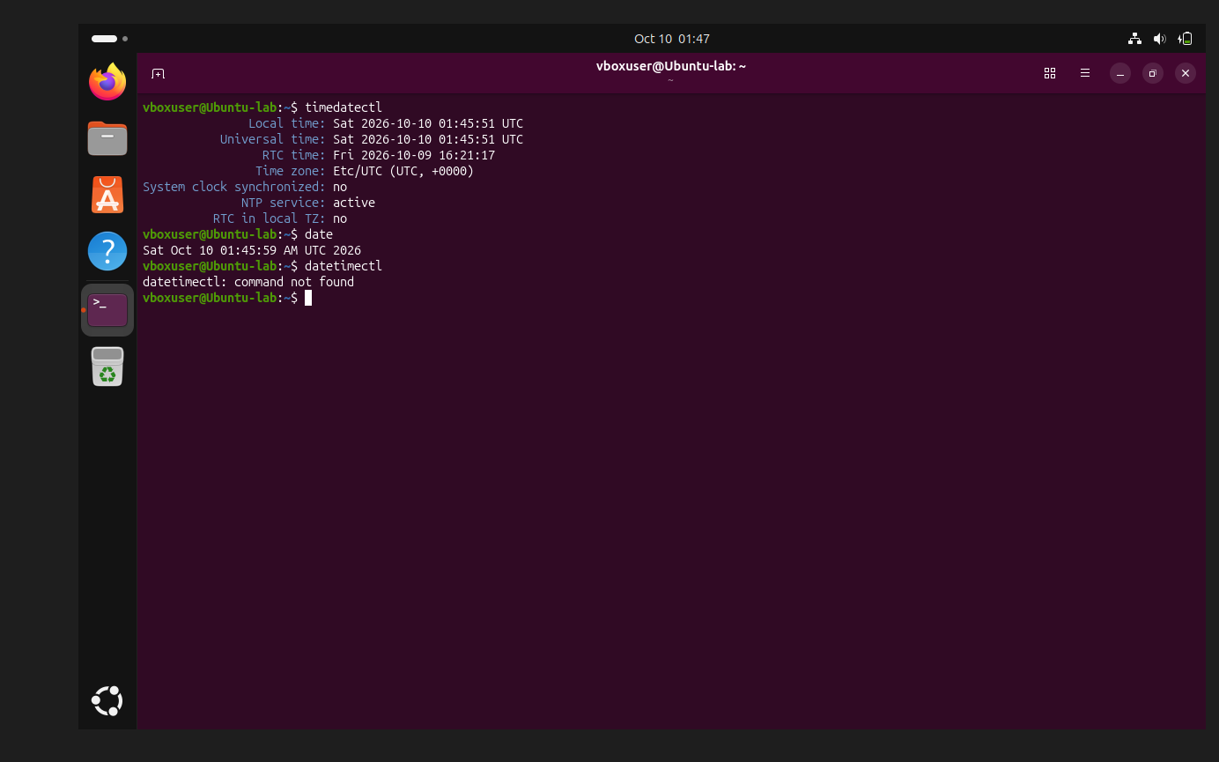
- Check the system uptime.
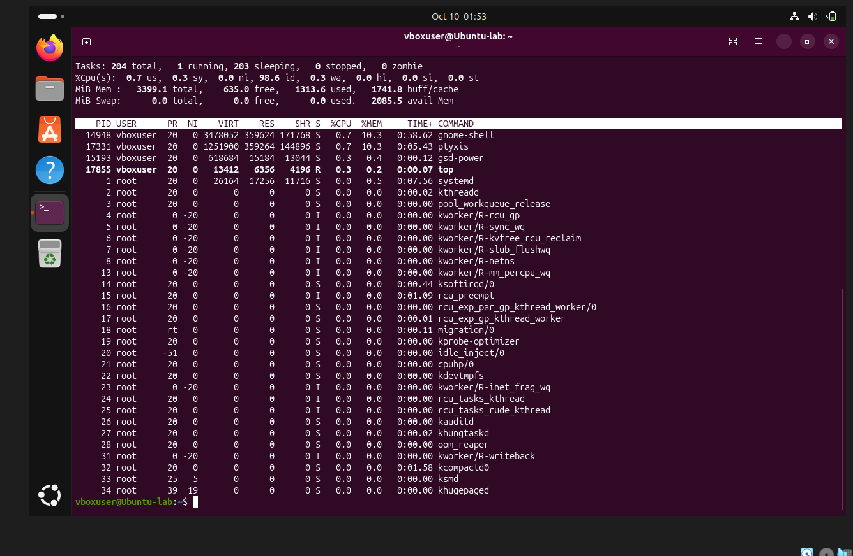
We can use uptime -p for system uptime (or) Top Command will use.
- View the running processes.
using ps -ef command will get the running process
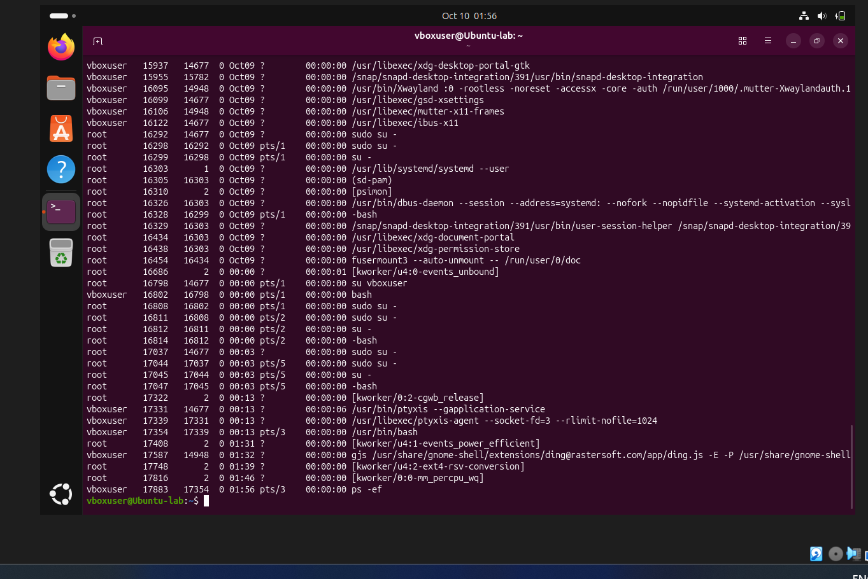
- Kill a running process.
First of all, just we need to try to stop the service/process through
systemctl stop service/process name
If it’s not working, we need to use kill -9 PID
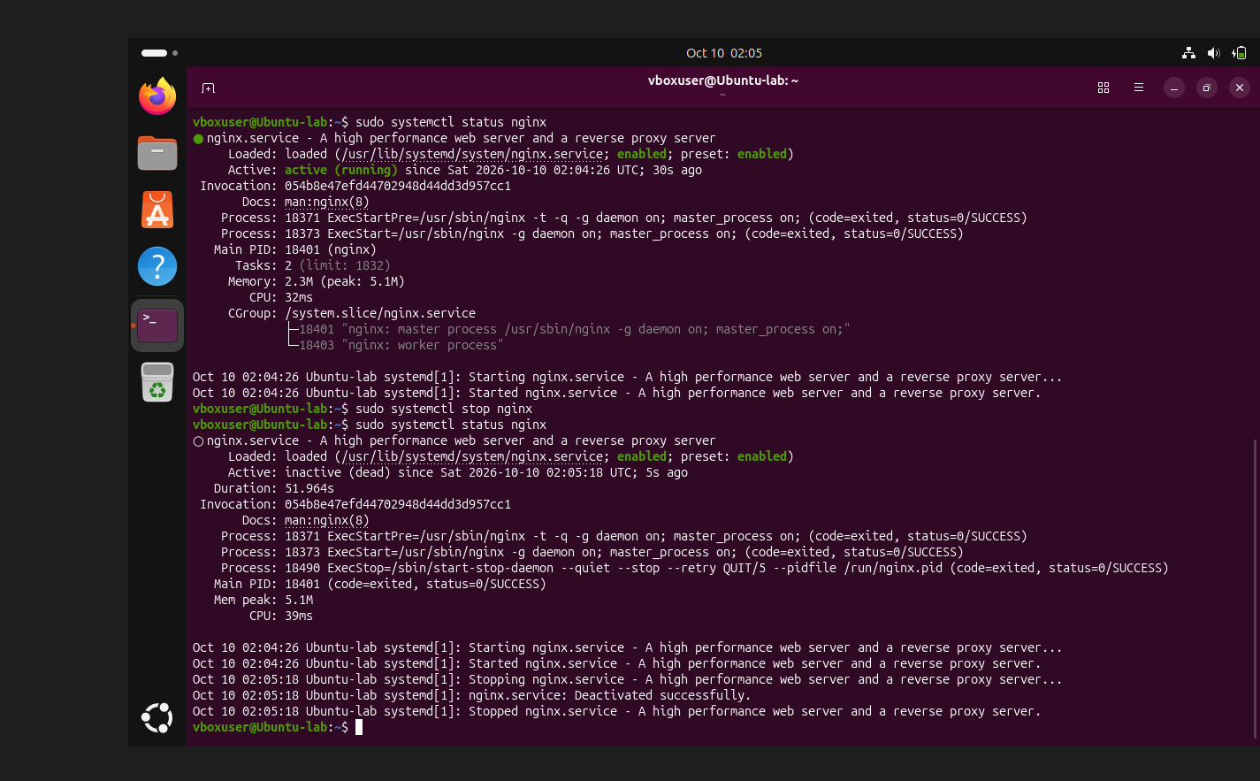
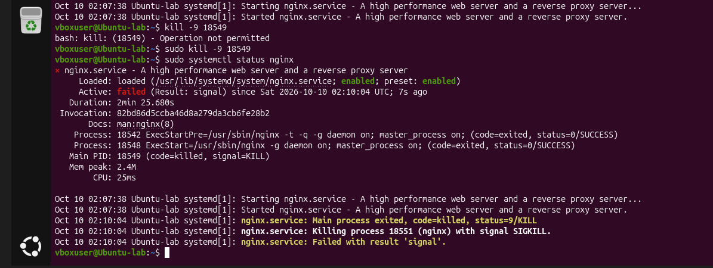
- Install a package using the package manager (e.g., apt or yum).
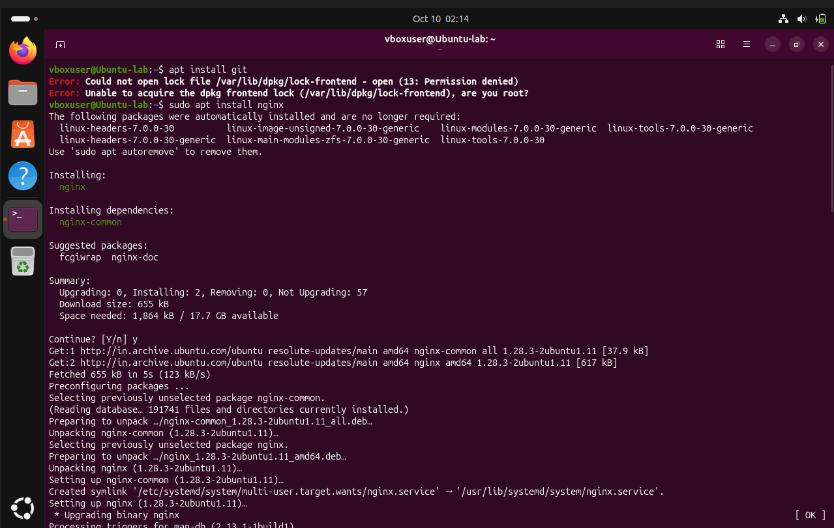
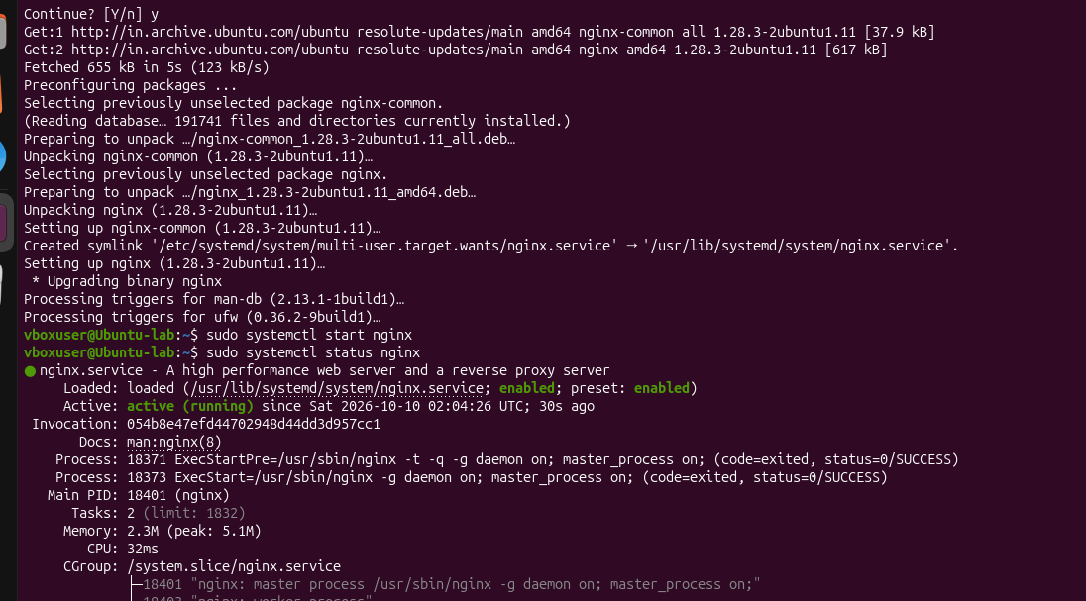
- Update the system packages.
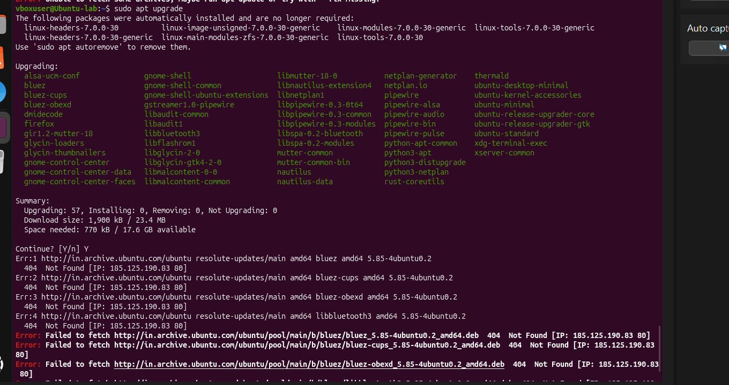
- Create a symbolic link.
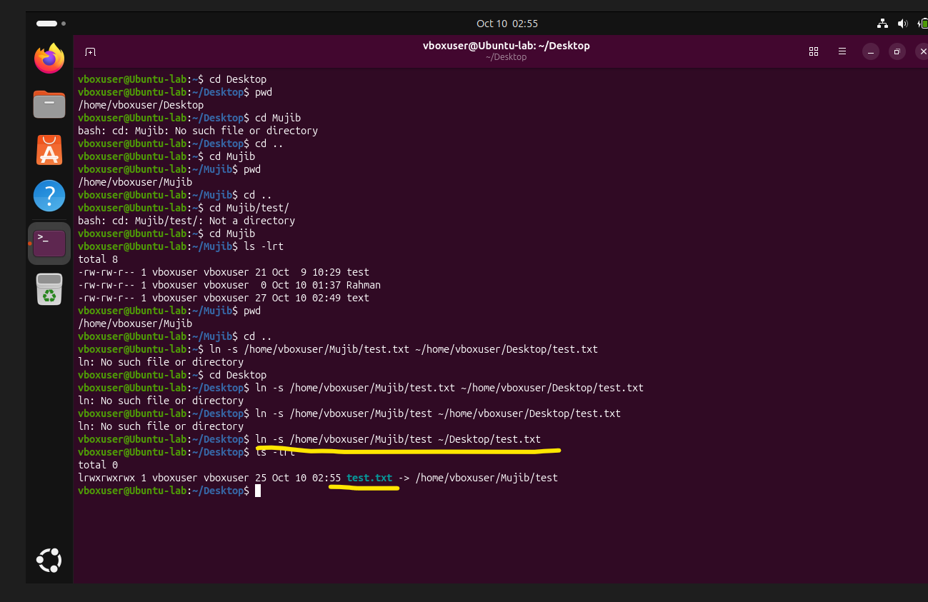
- Search for files using the find command.
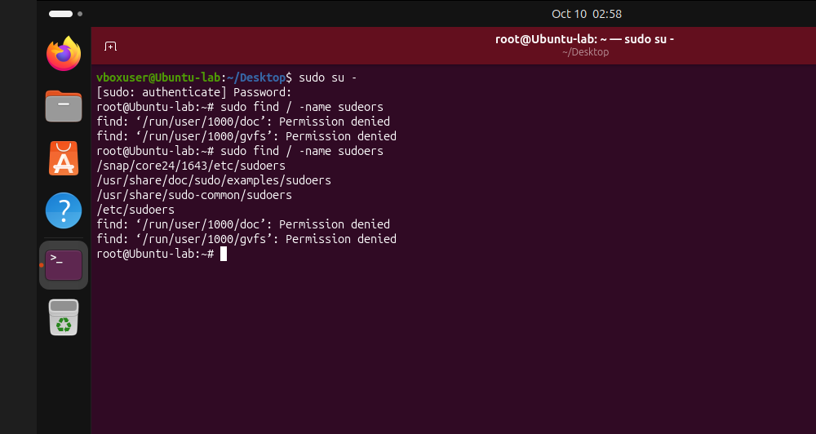
- Compress and decompress files using tar.
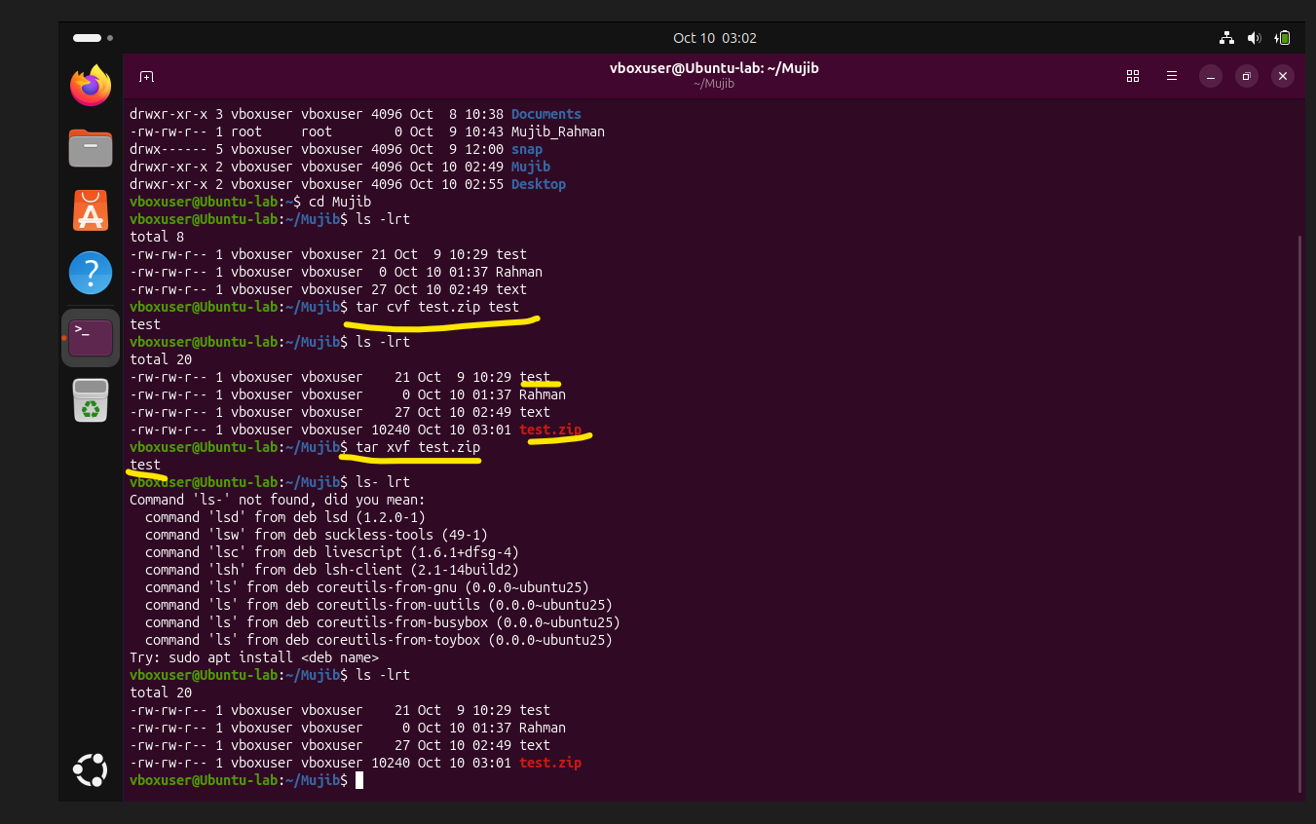
- Monitor system resources with top or htop.
- Create and manage user groups.
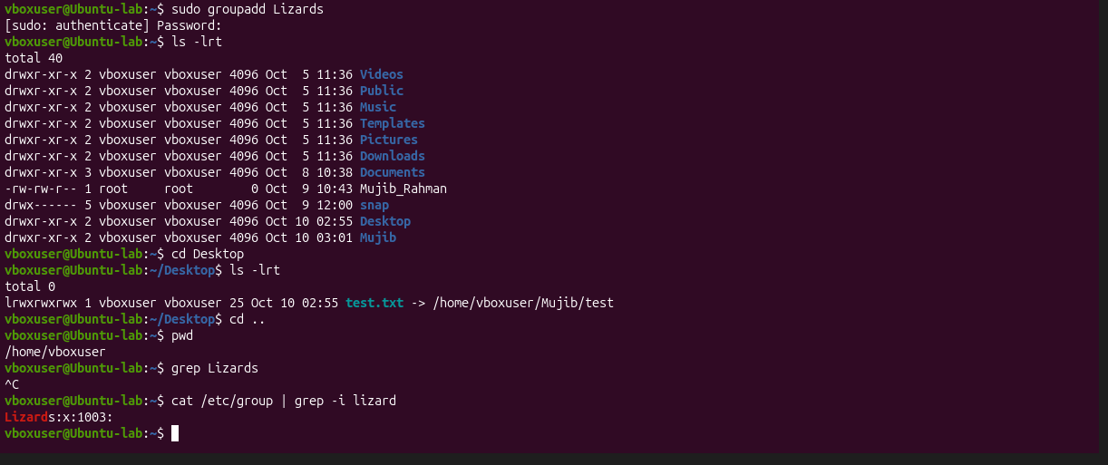

- Set up SSH password less authentication.
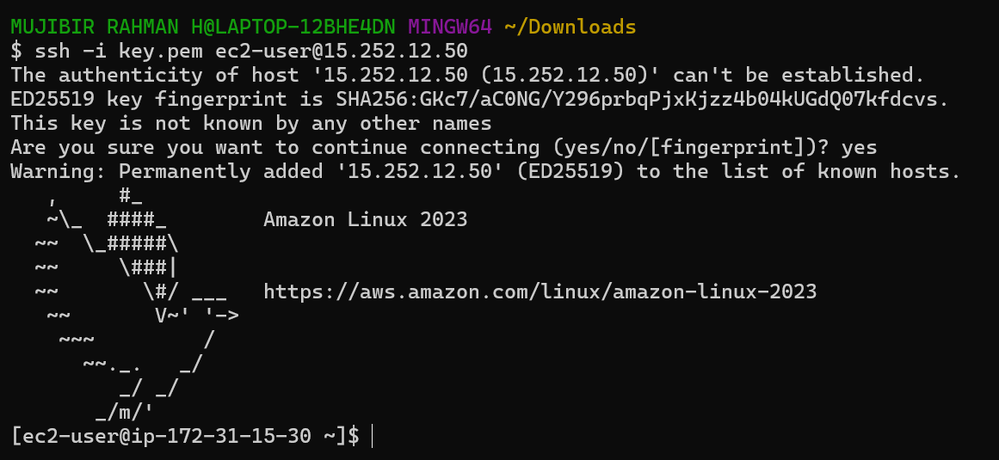
- Monitor log files using tail or grep.
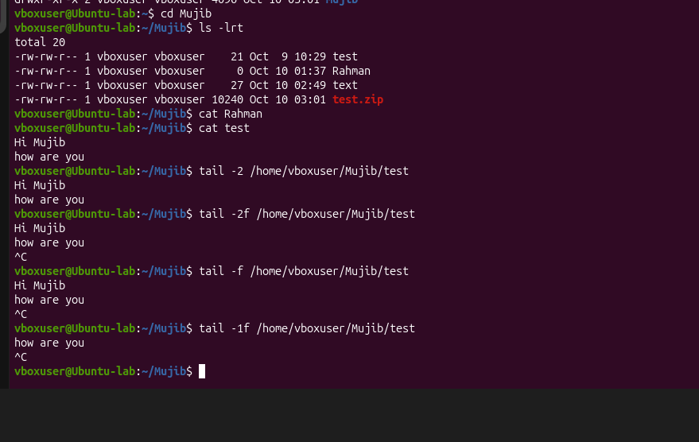
- Set up a web server (e.g., Apache or Nginx).
- Configure and secure a MySQL Database.
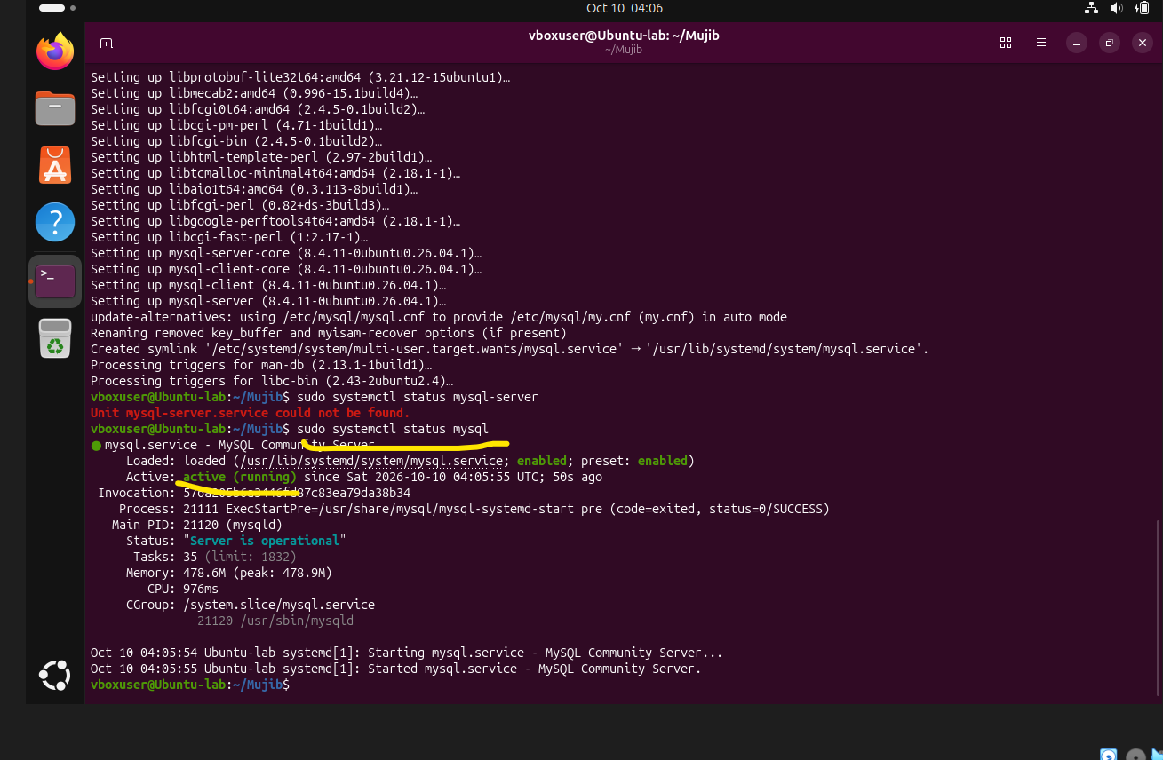
- Set up a Application Server (e.g.,Apache Tomcat)
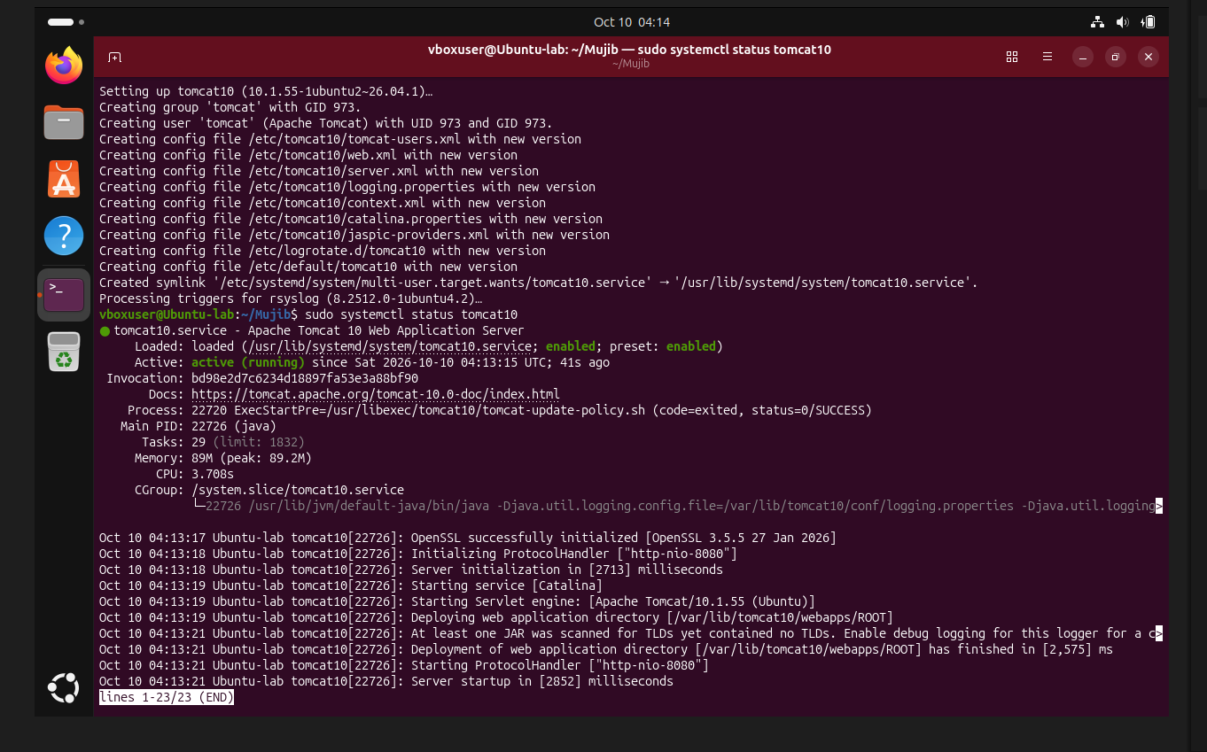
- create a service file for Apache Tomcat. (Should execute by using systemtctl command)
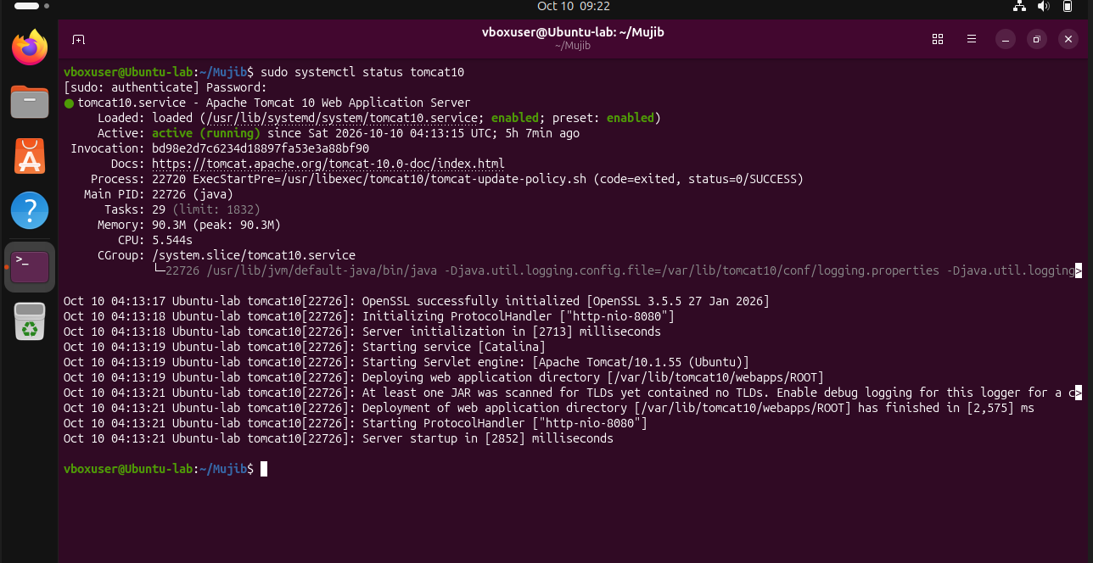
- Print specific columns from a delimited file.
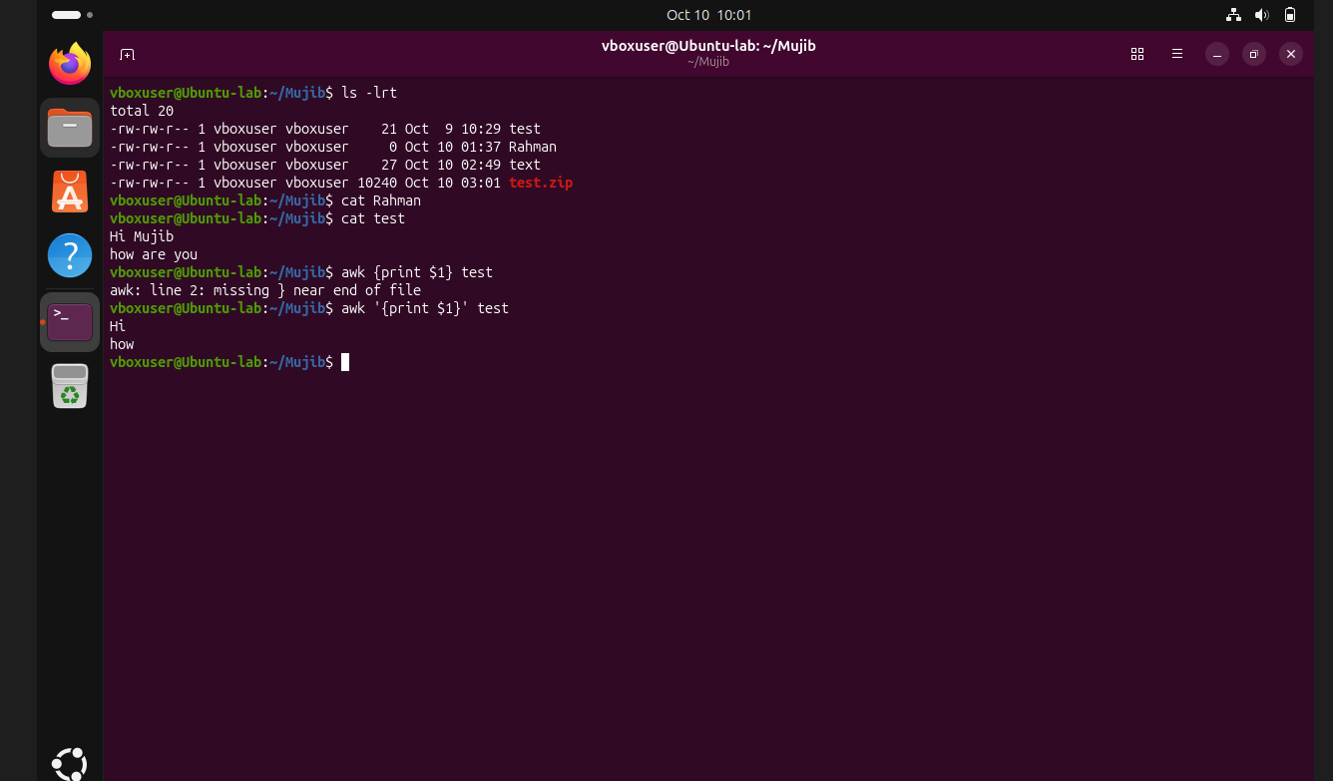
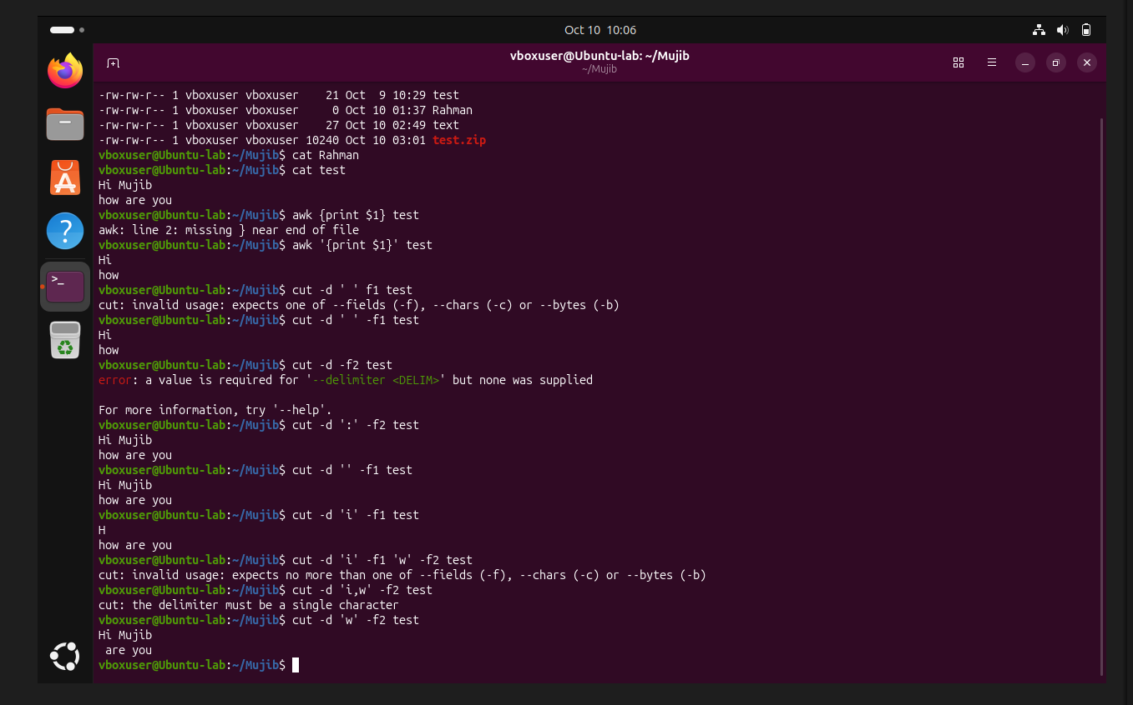
- Filter and print lines based on a specific pattern or condition.
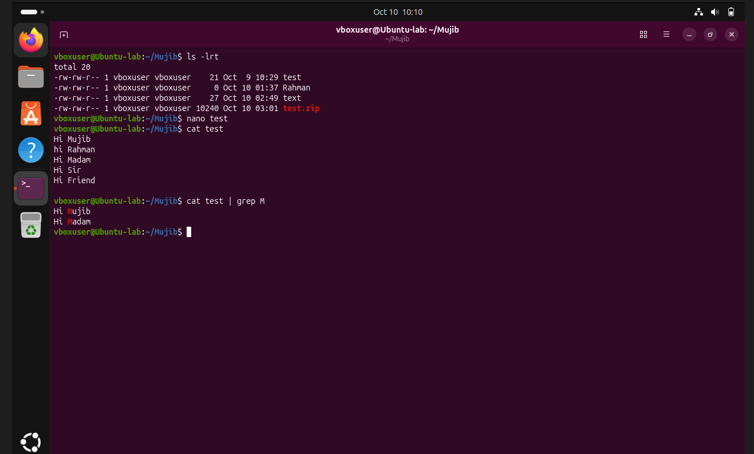
- Calculate and print the average, sum, or other statistics of a column.
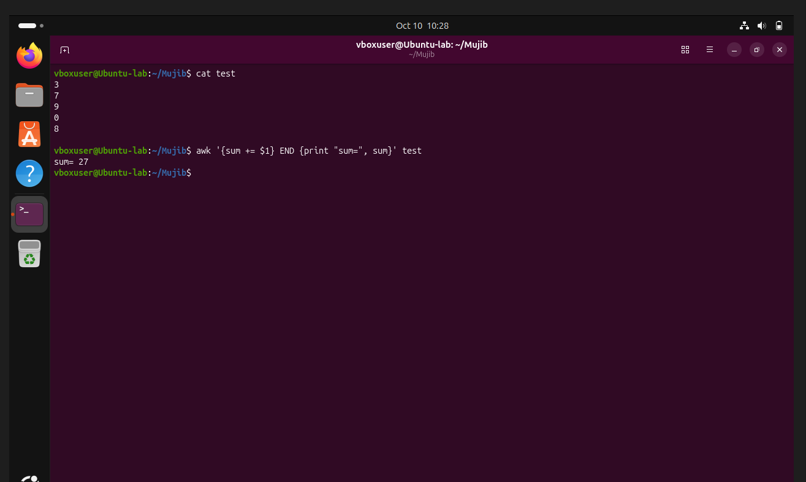
- Perform string manipulation, such as extracting substrings or changing case.
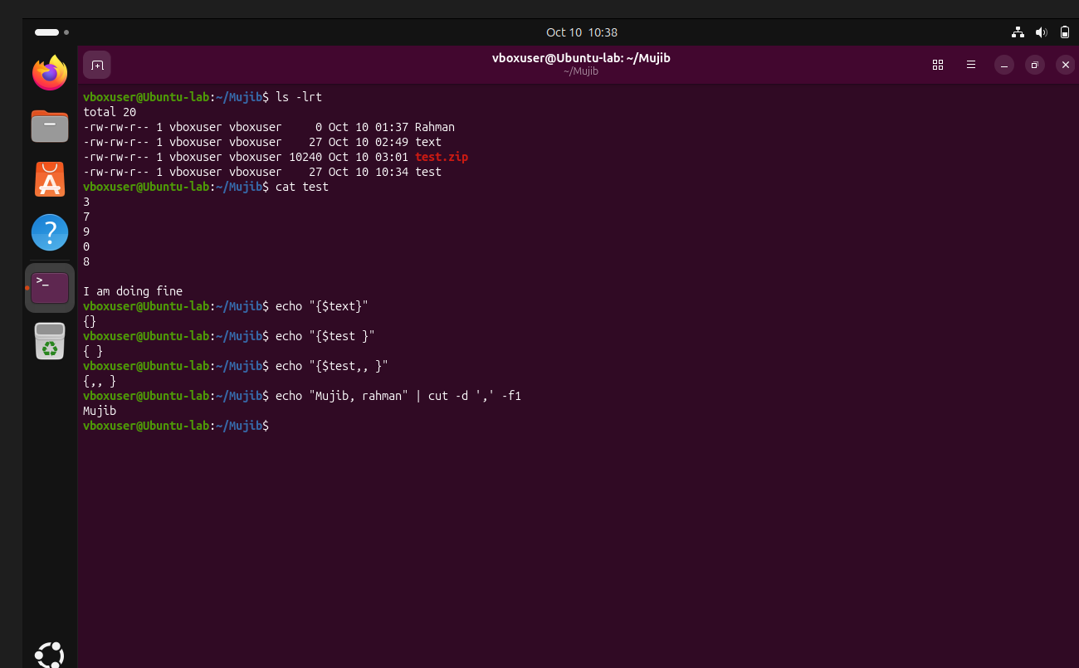
- Count the occurrences of a specific pattern in a file.
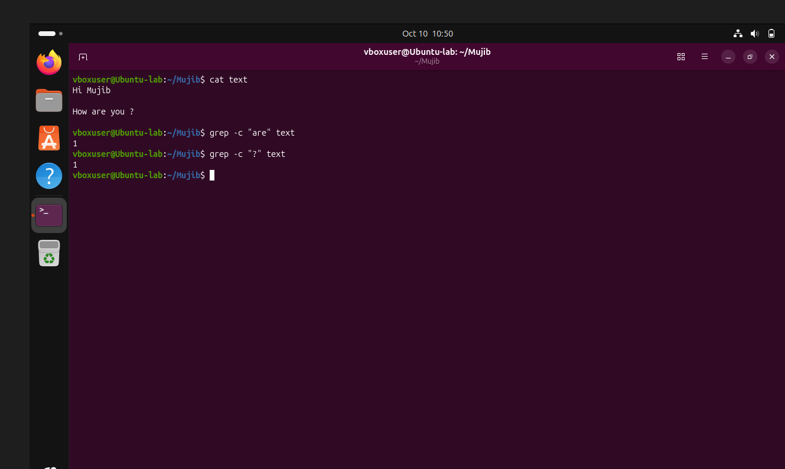
- Sort lines based on a specific field or column.
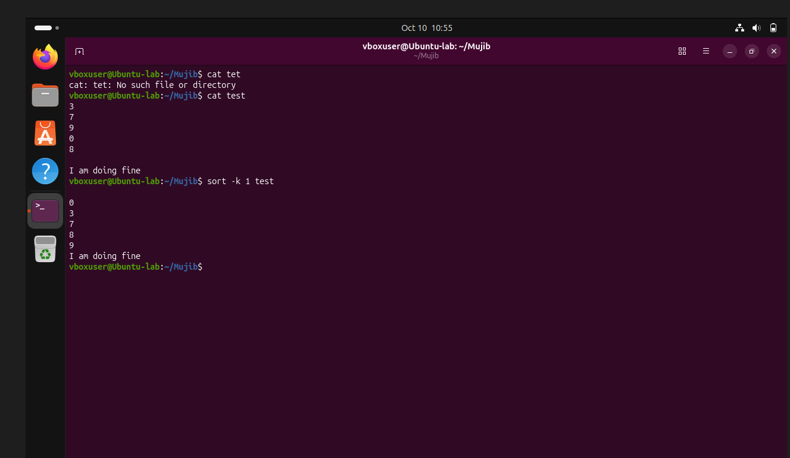
- Merge multiple files based on a common field or column.
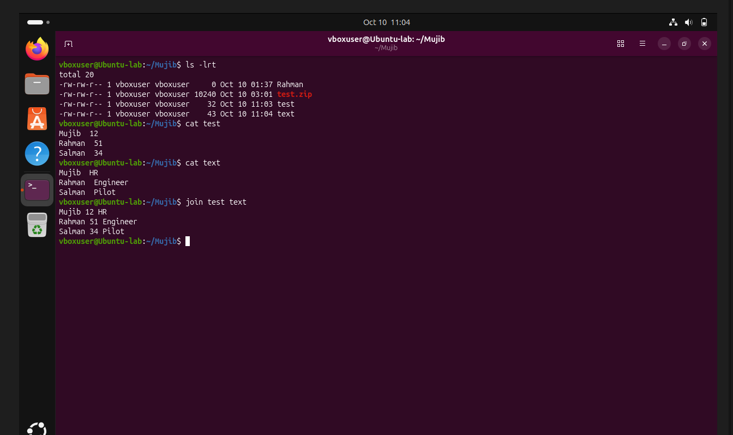
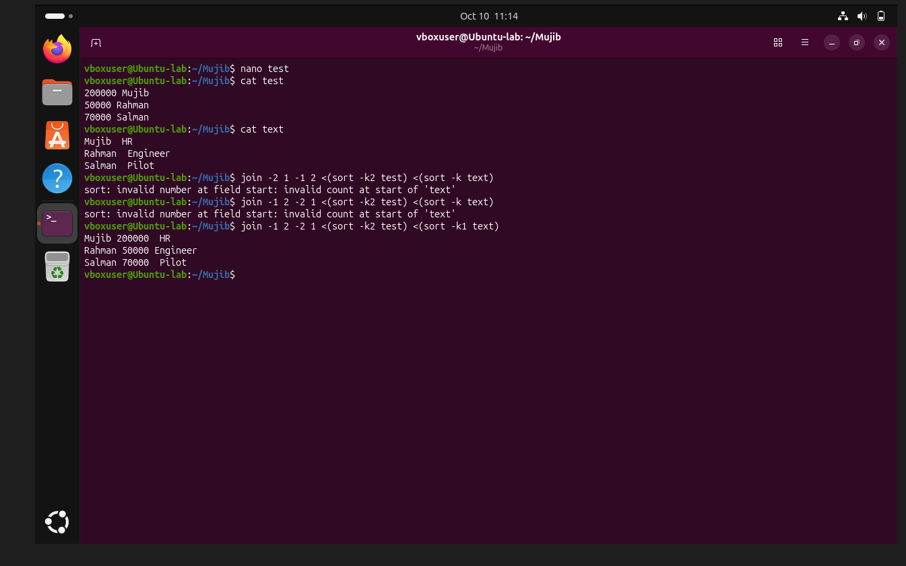
- Substitute text in a file using search and replace.
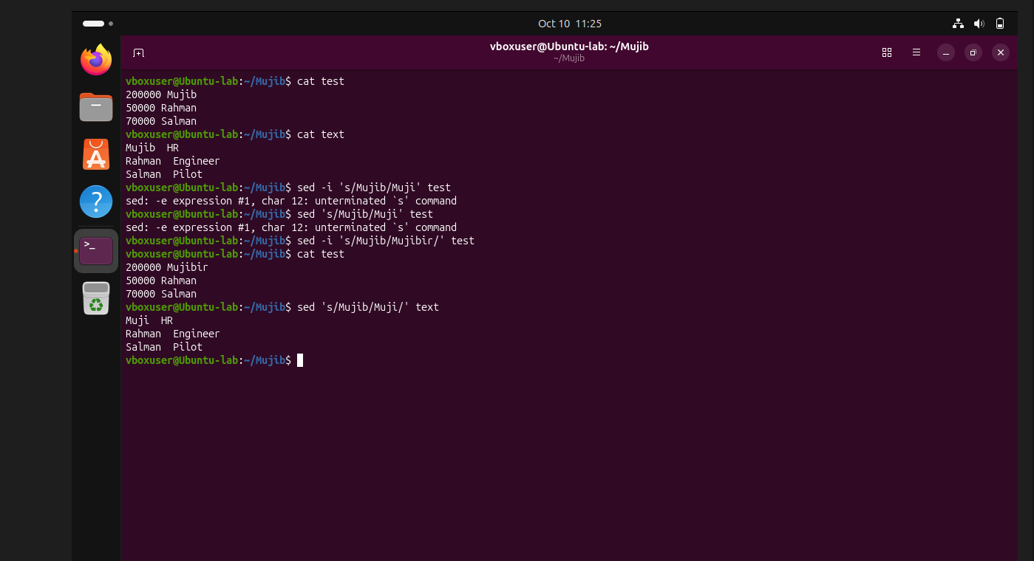
- Delete specific lines based on a pattern or line number.
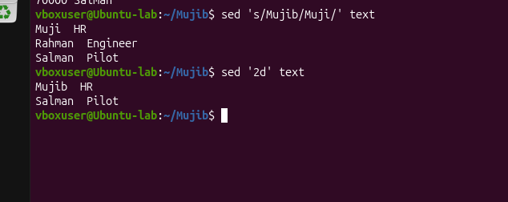
- Append or insert text before or after a specific pattern or line.
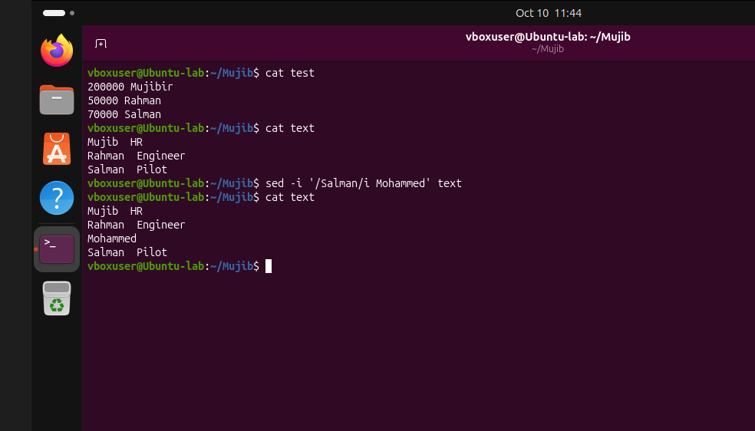
- Print only specific lines from a file.
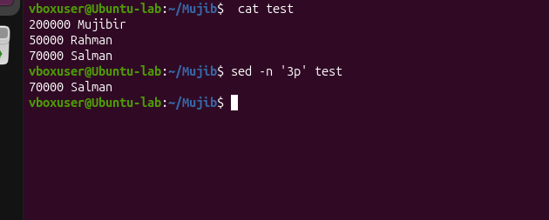
- Copy file from linux to windows machine
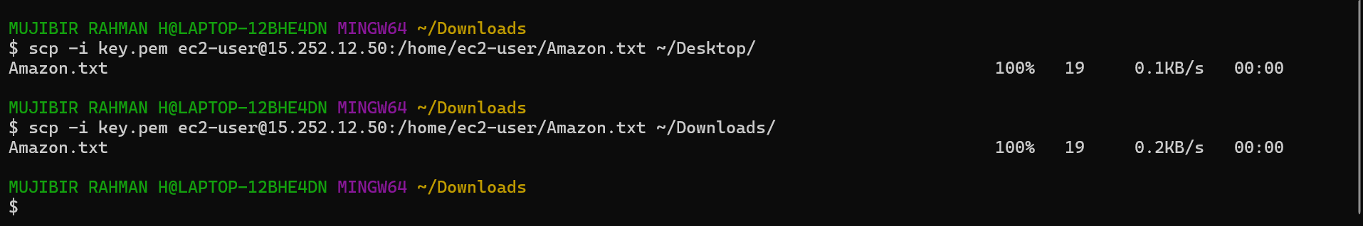

- 5 use cases for AWK and 5 use cases for sed
